Chem 200 Exam 2 Study Guide

Kinetic/Potential Energy
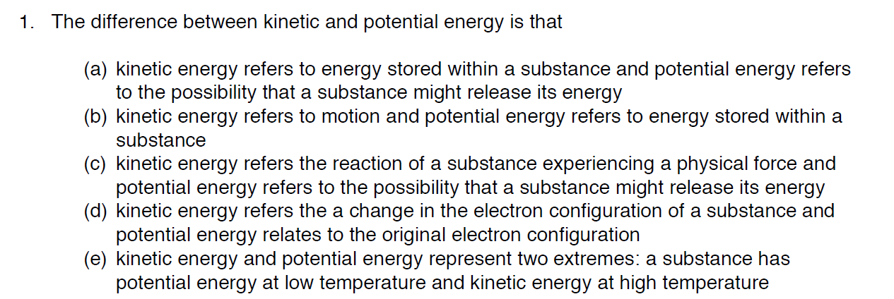

Endothermic/Exothermic
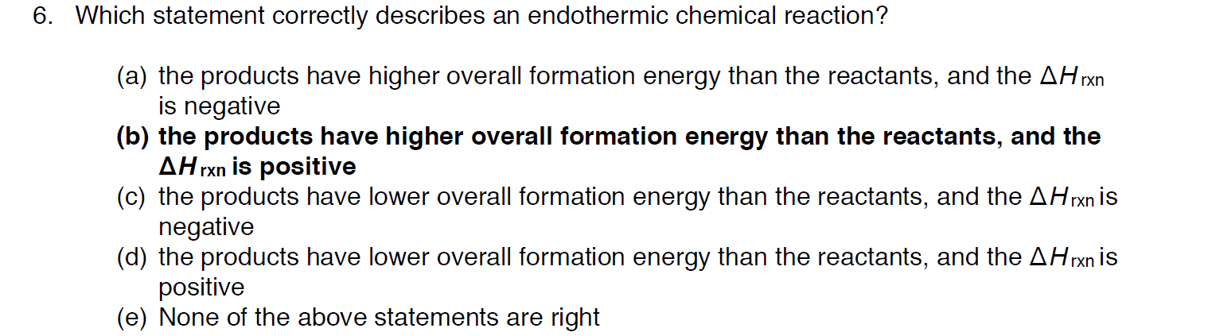
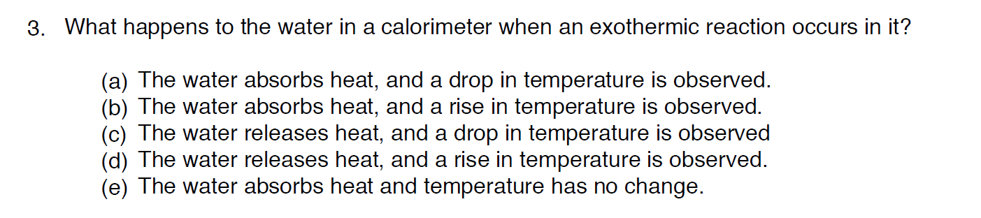

State Functions
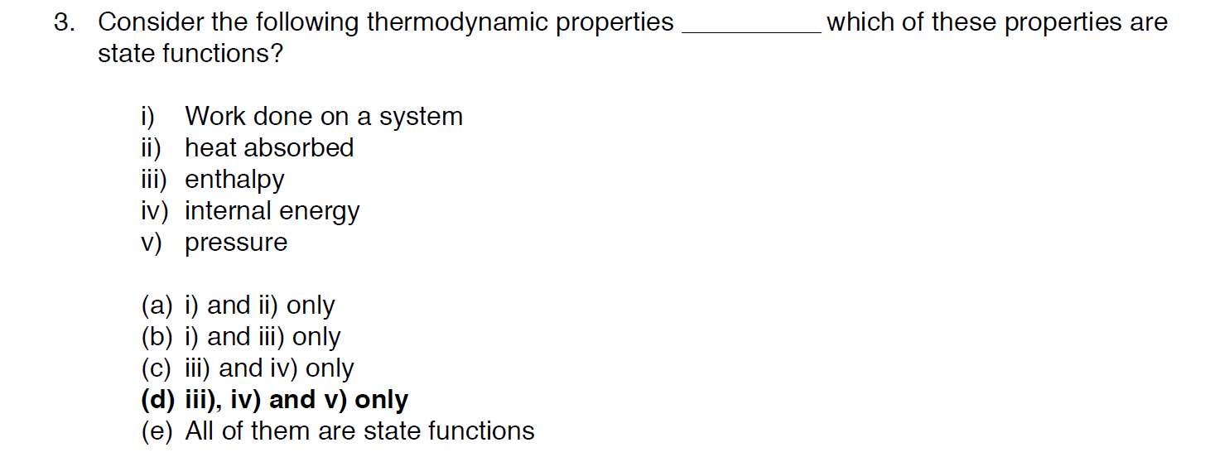
Change in Internal Energy
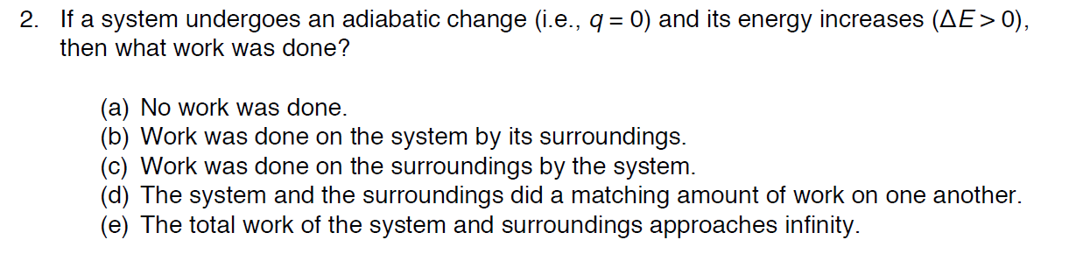

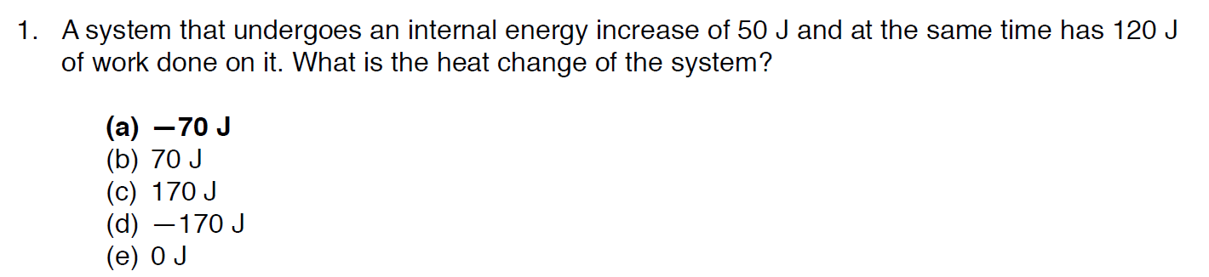

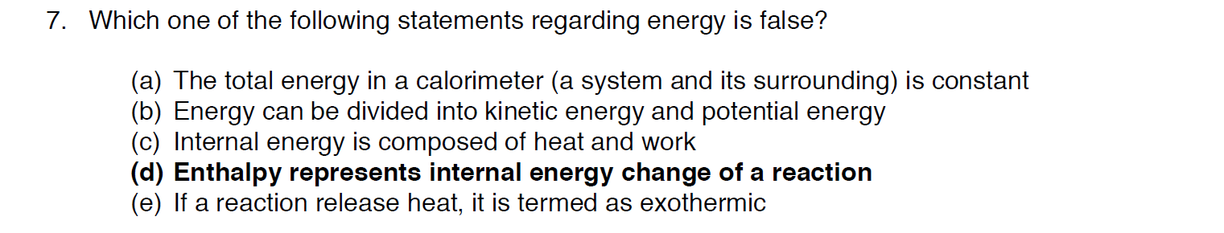

Calorimetry
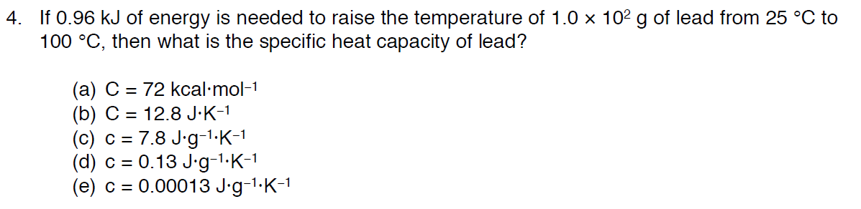

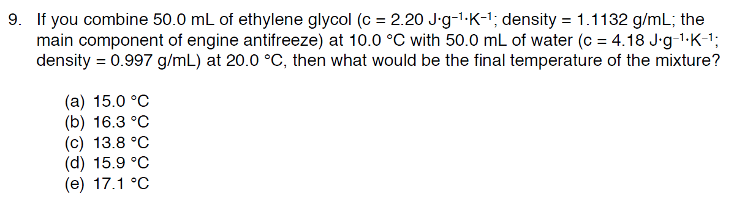

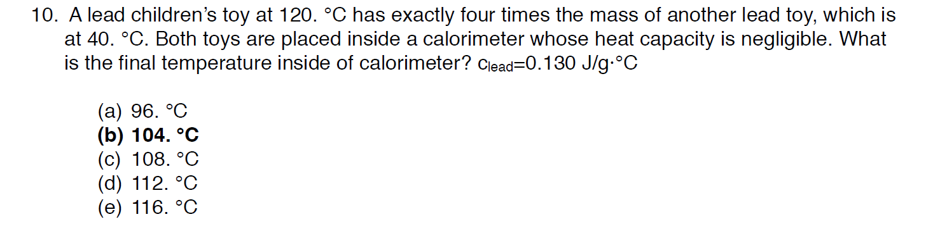

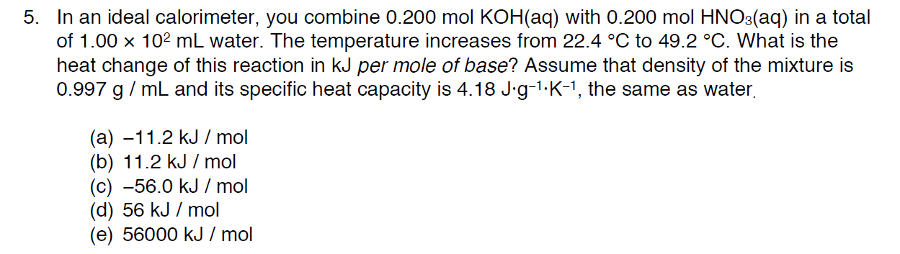

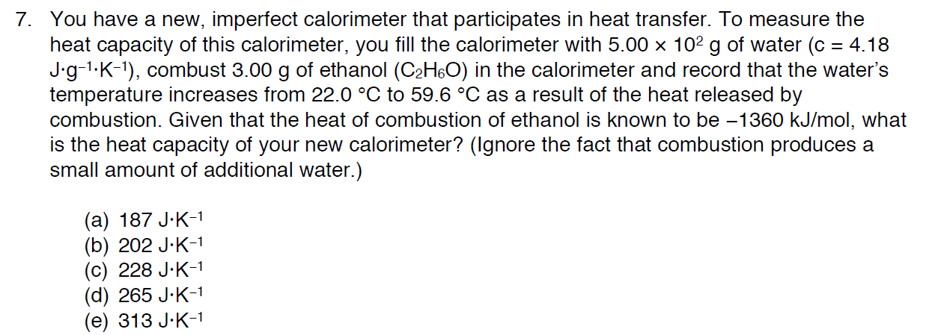

Formation Reactions
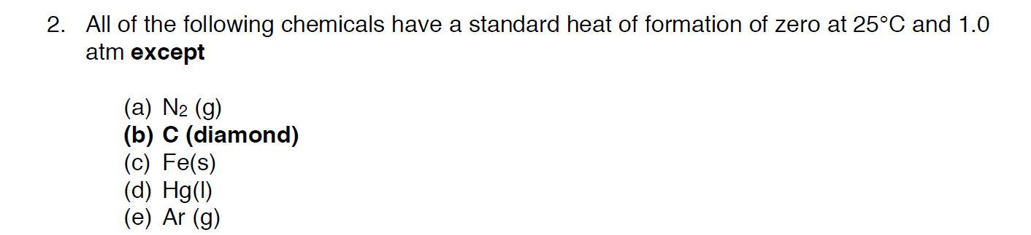
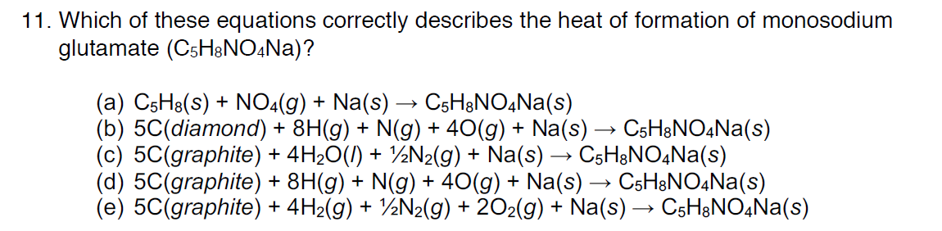
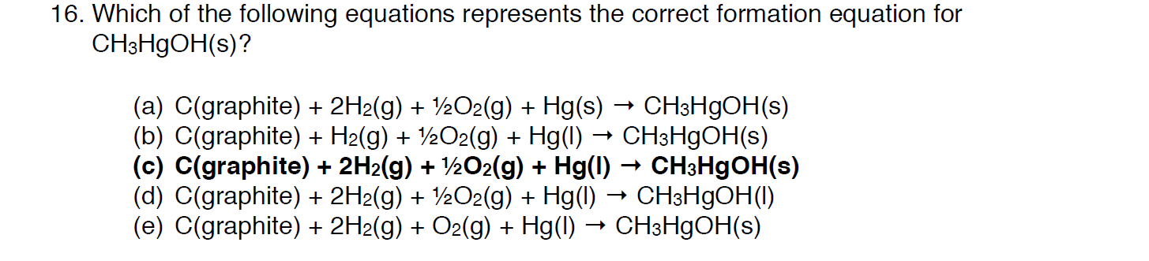
Delta H and Heat of Formations

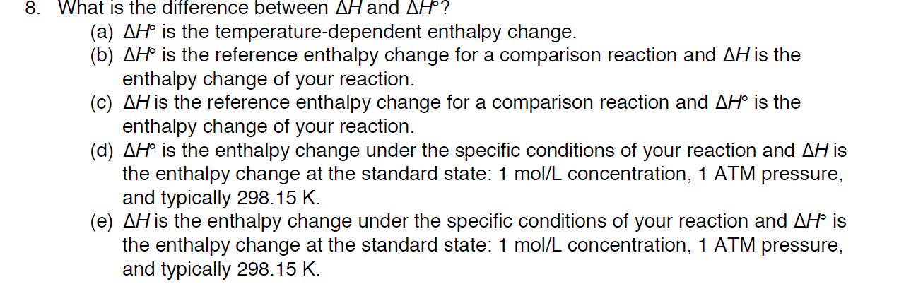

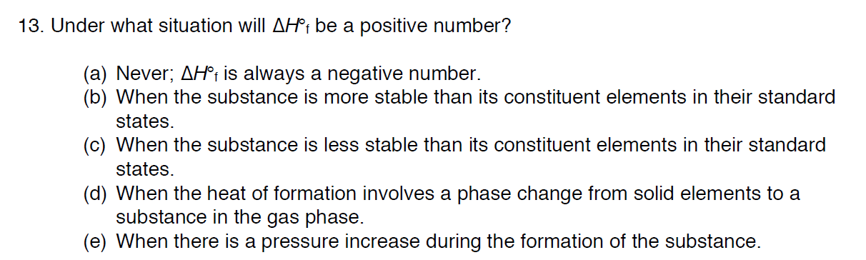
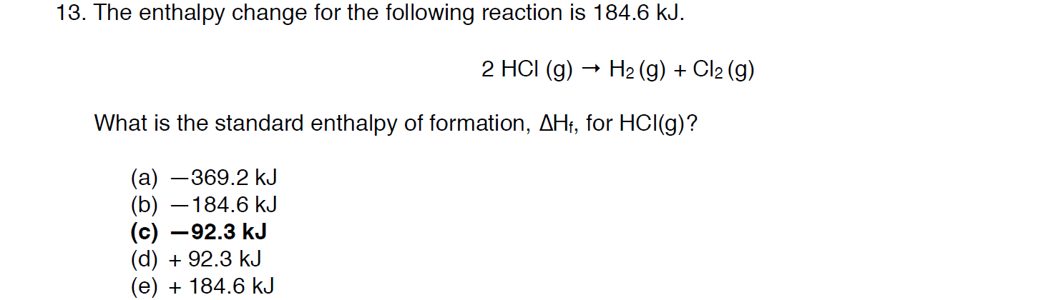

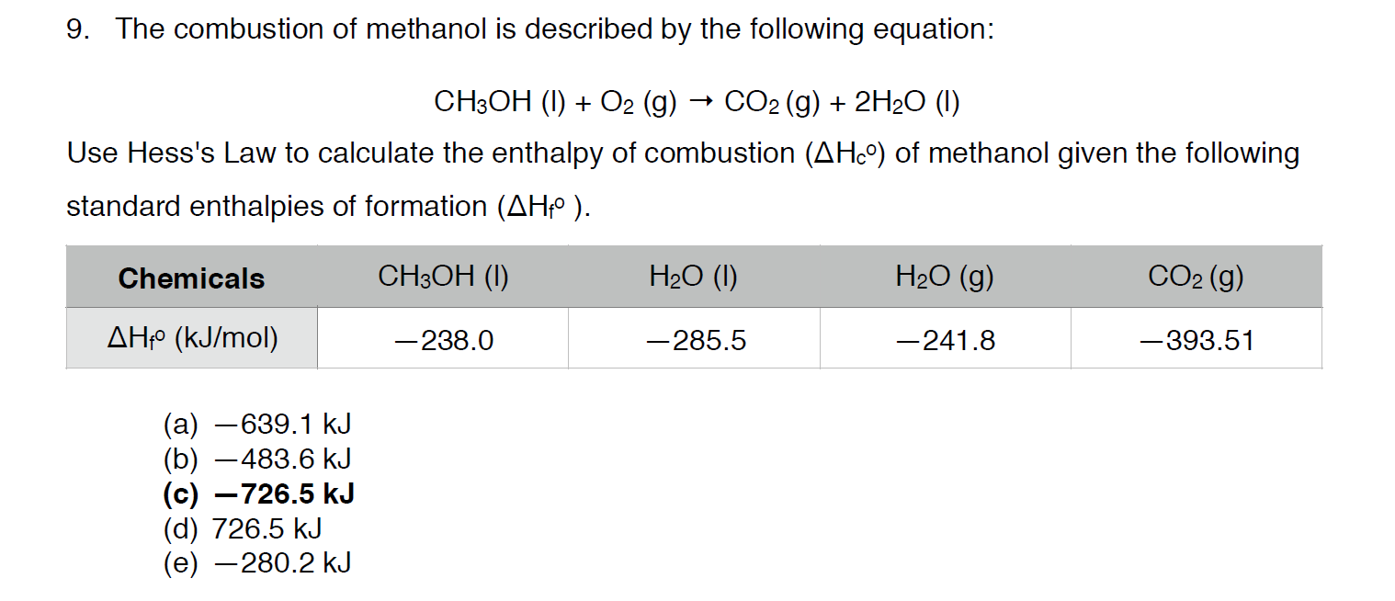
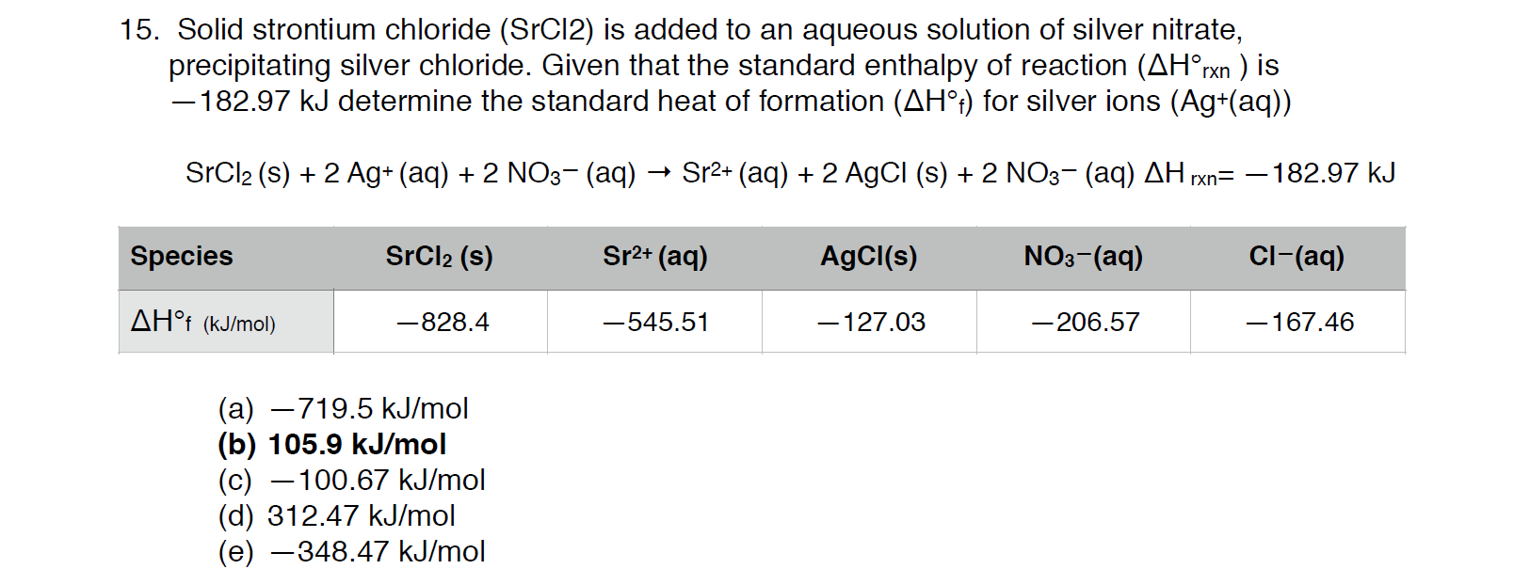

Heat Stoichiometry
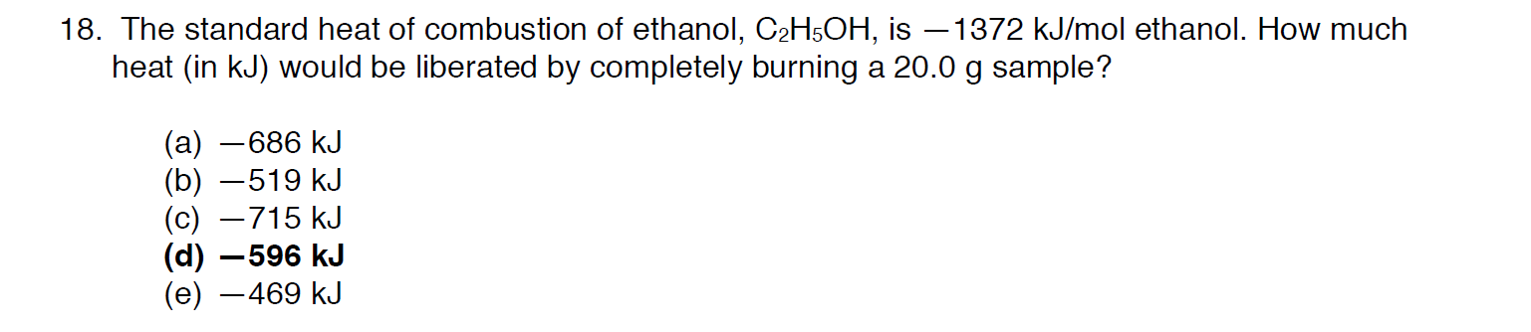

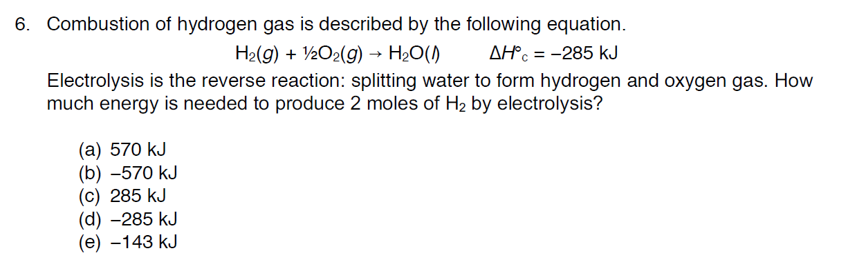

Hess’s Law
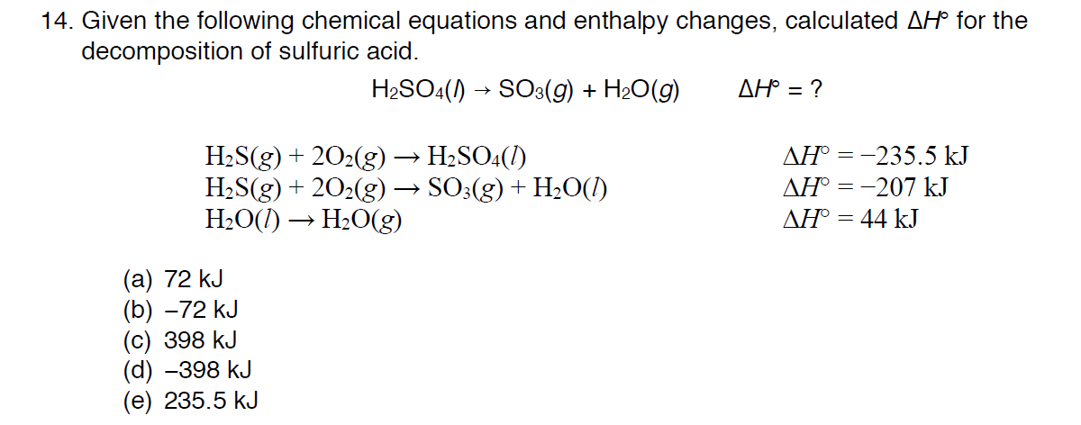

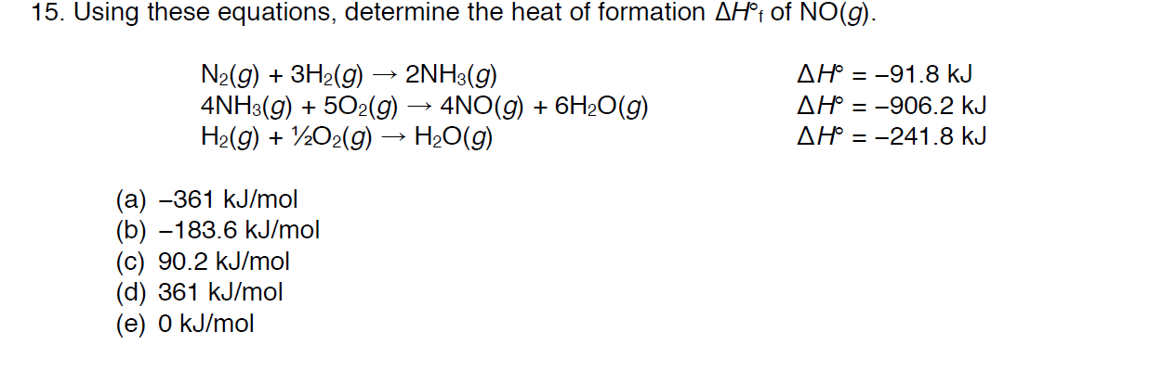

Light
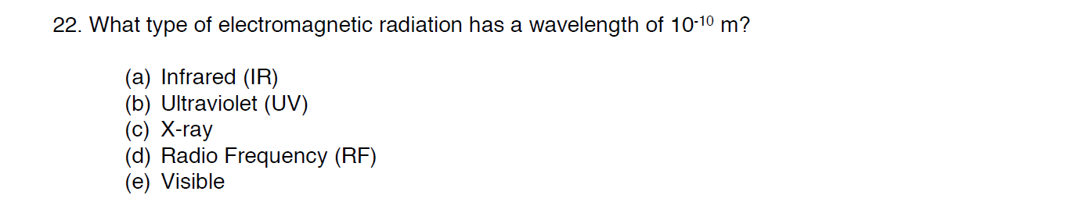
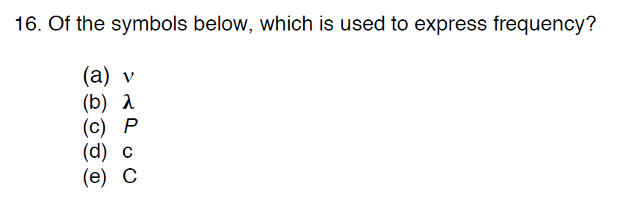
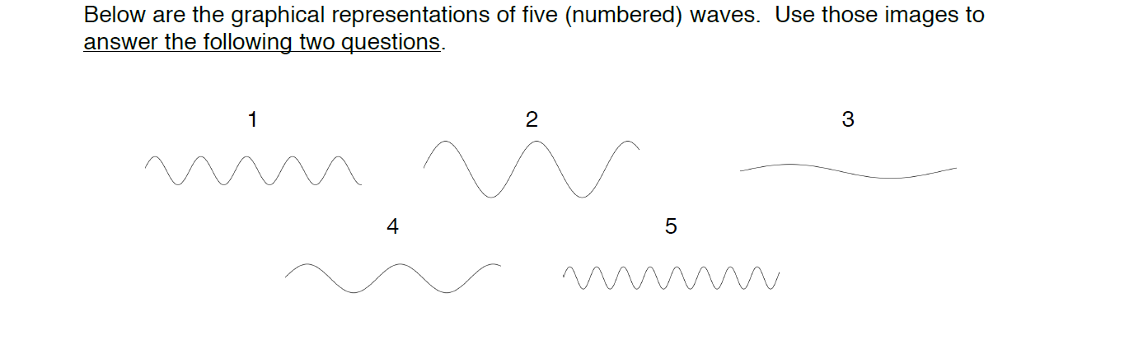
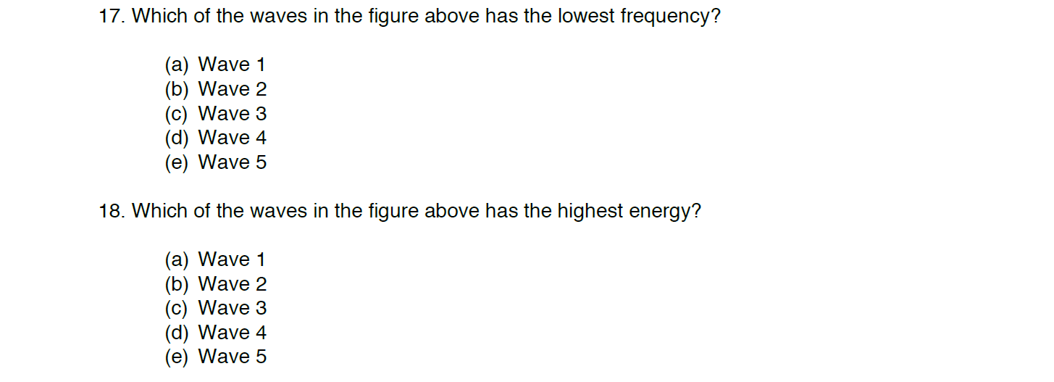

Light Calcs
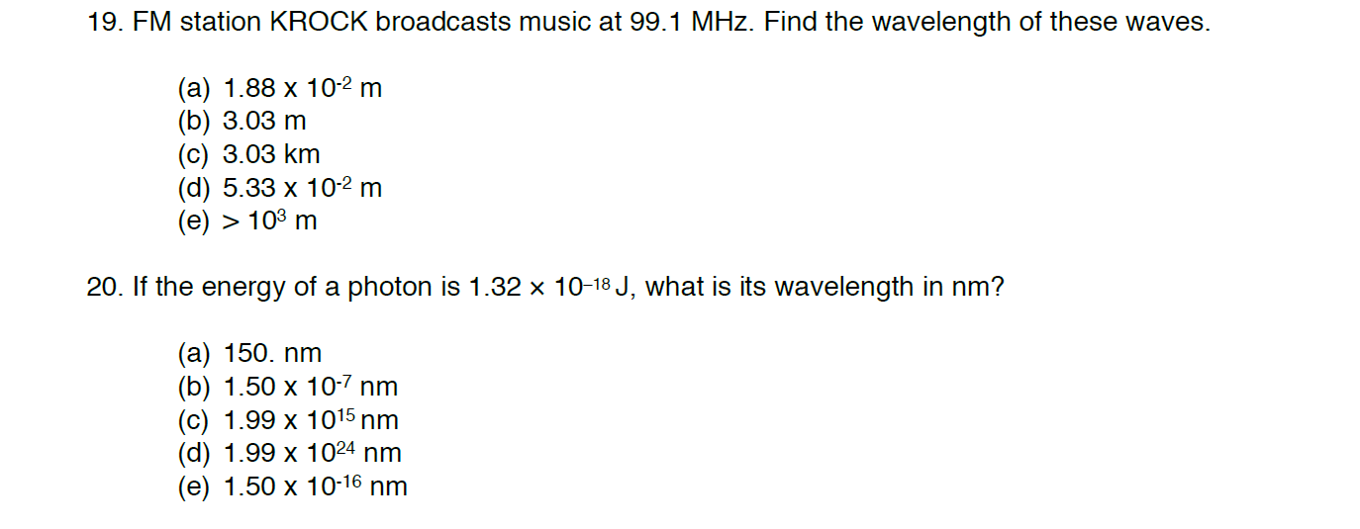

Blackbody Radiation
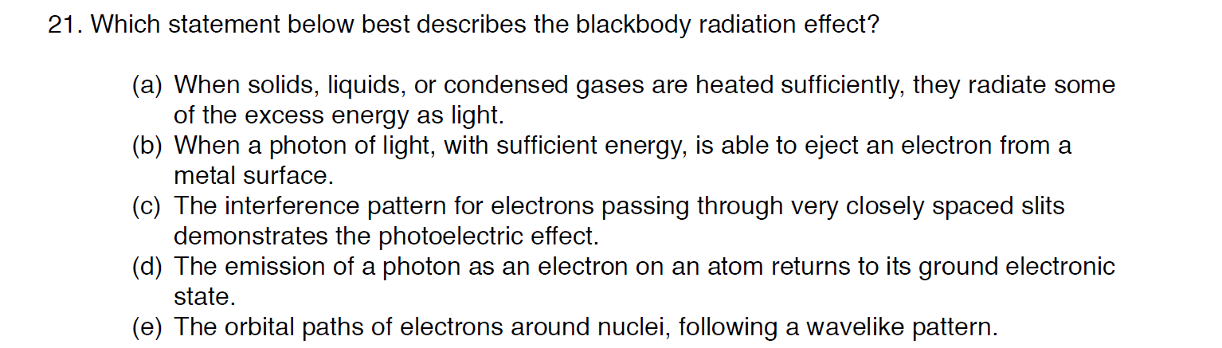
Photoelectric Effect
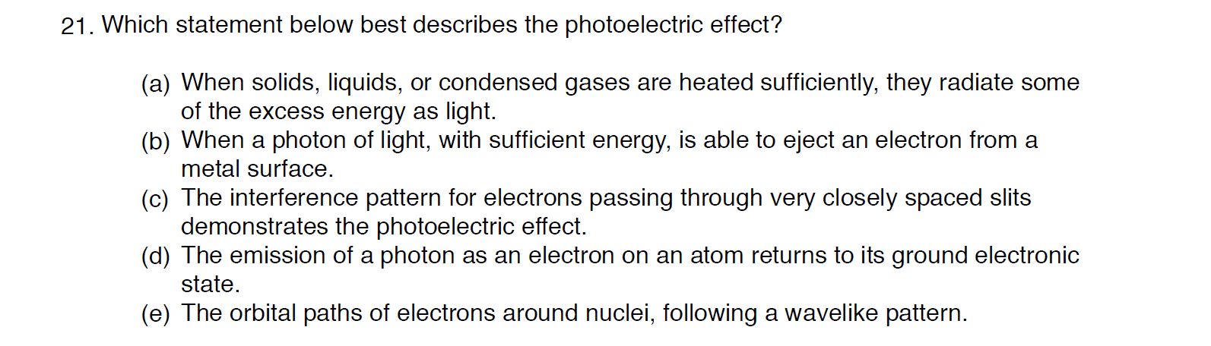
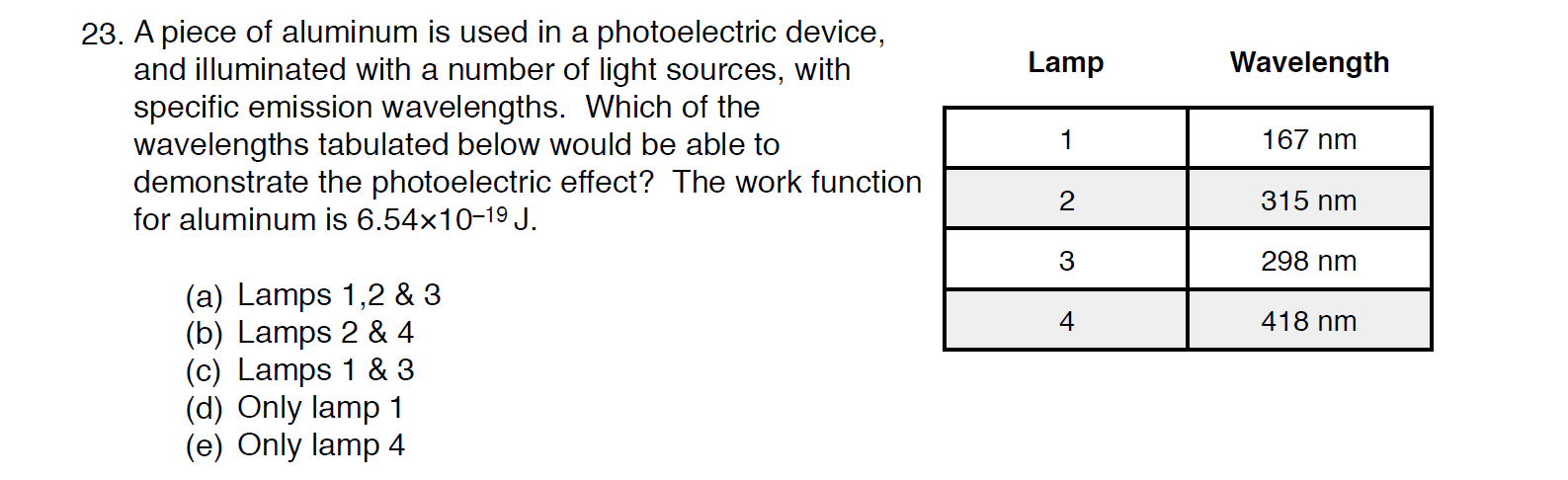

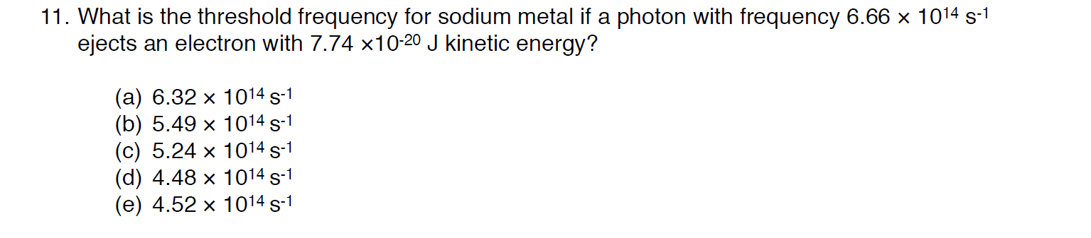

Electron Transitions
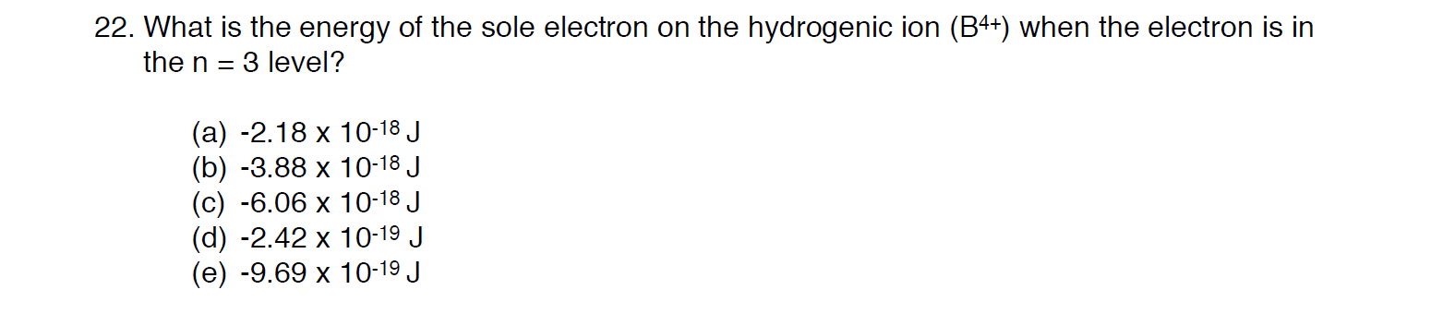

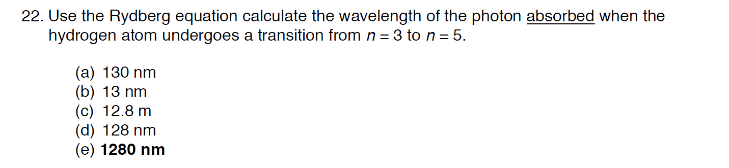
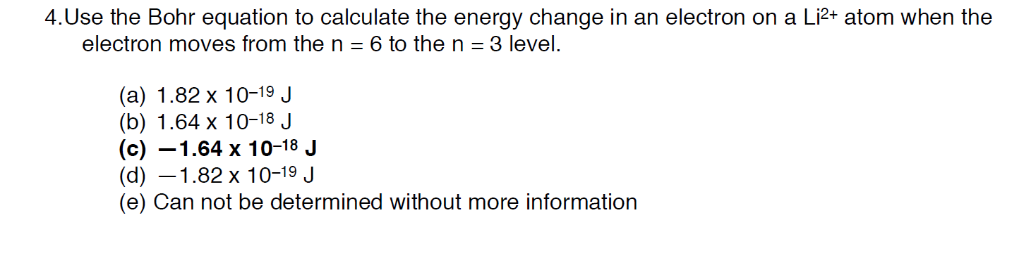

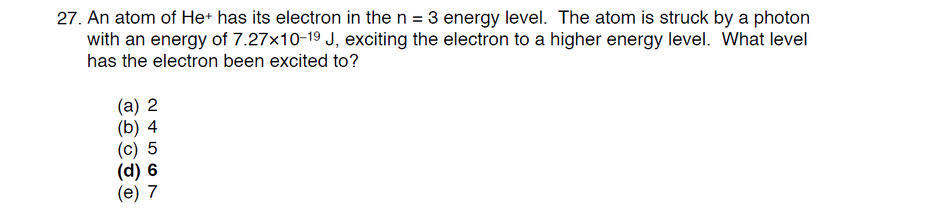

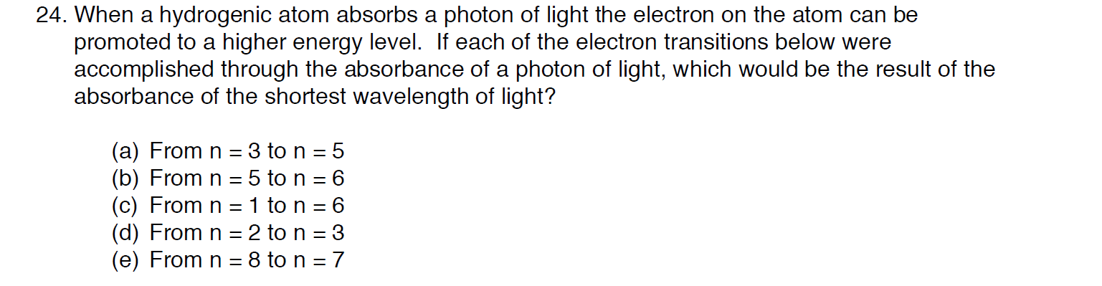

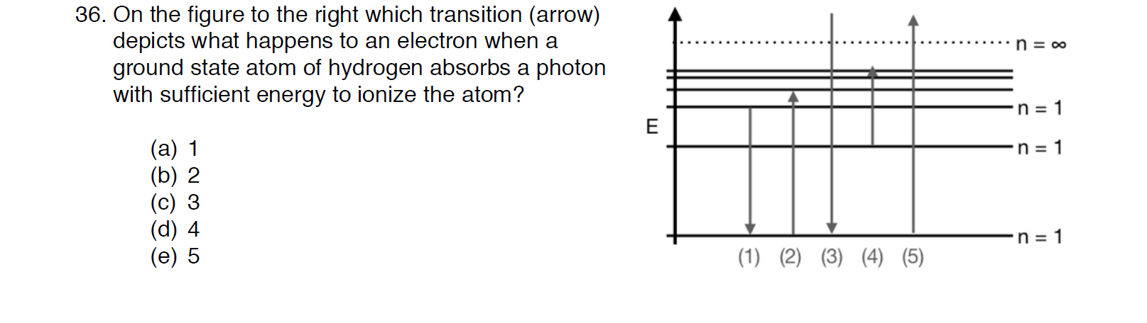
Wave-Particle Duality

deBroglie
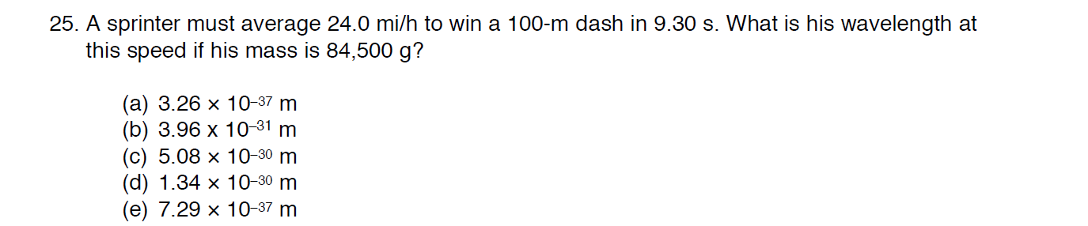

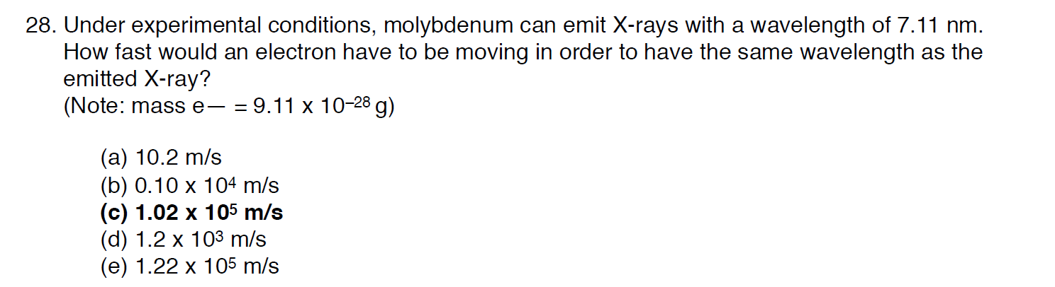

Heisenberg Uncertainty
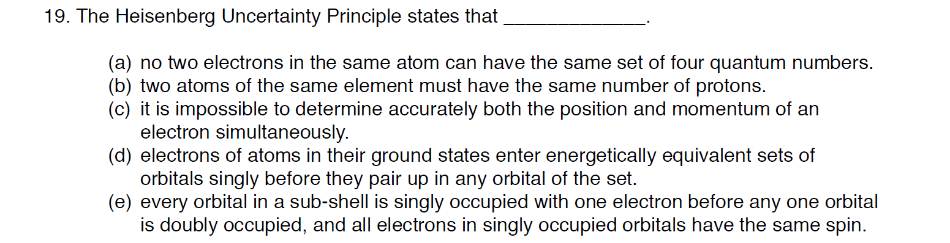
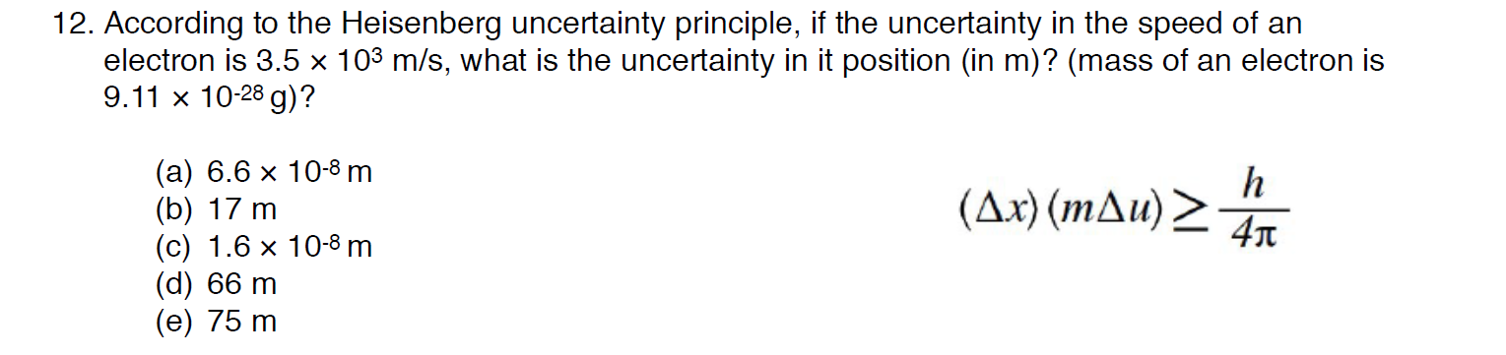

Quantum Numbers
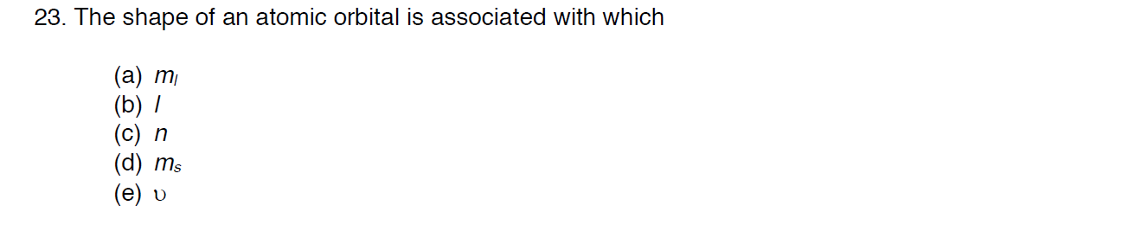
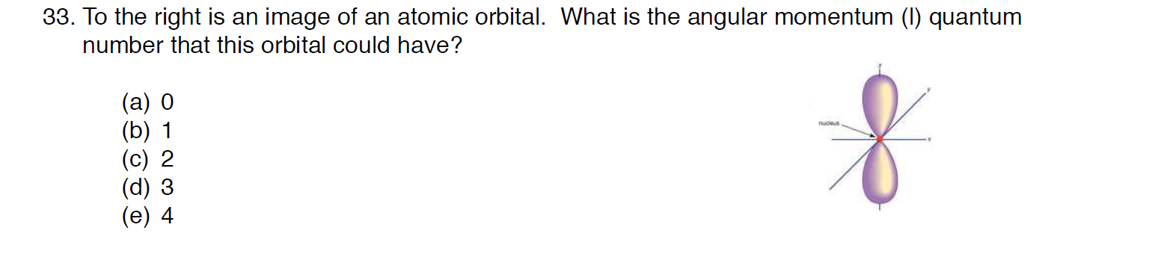
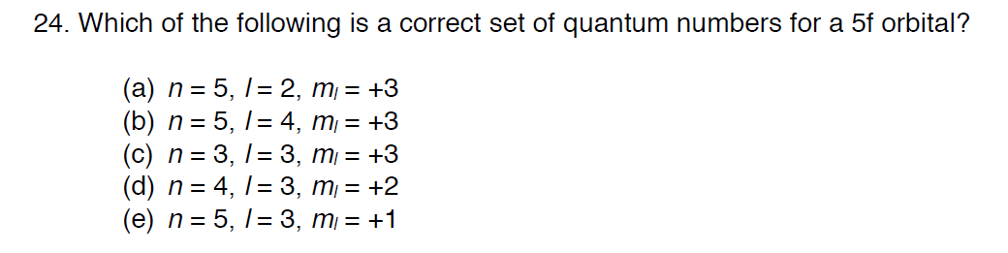
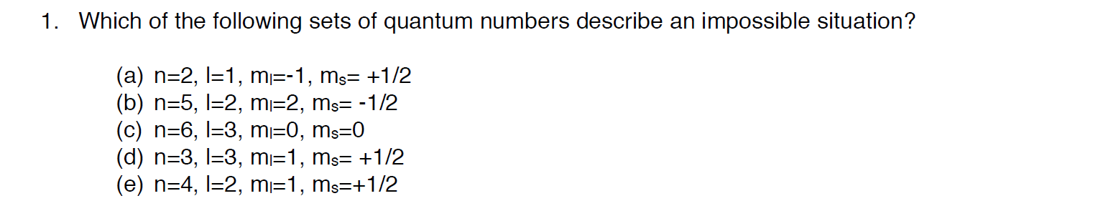
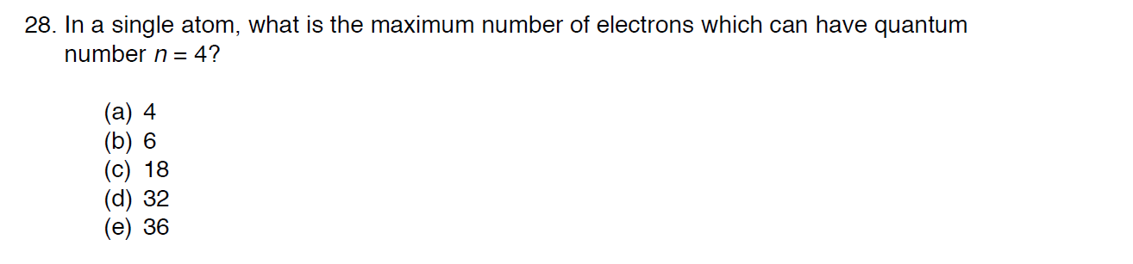

Electron Configurations
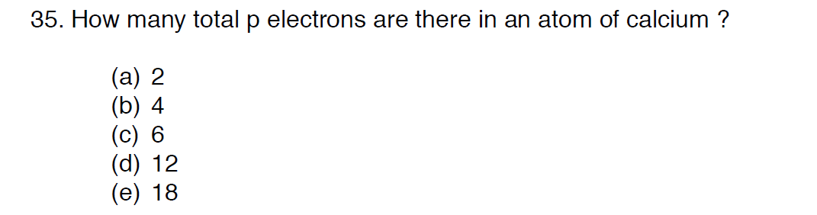
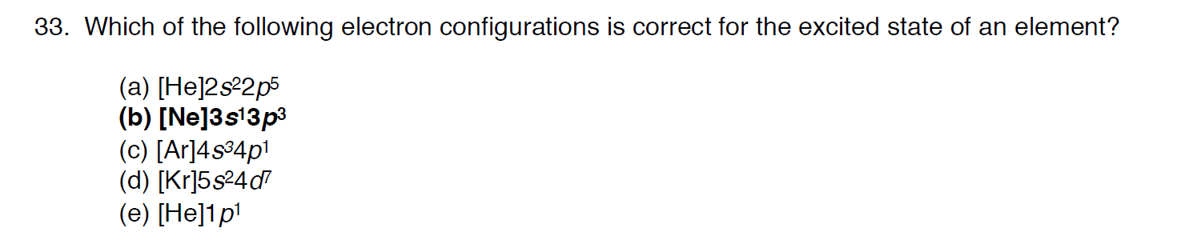
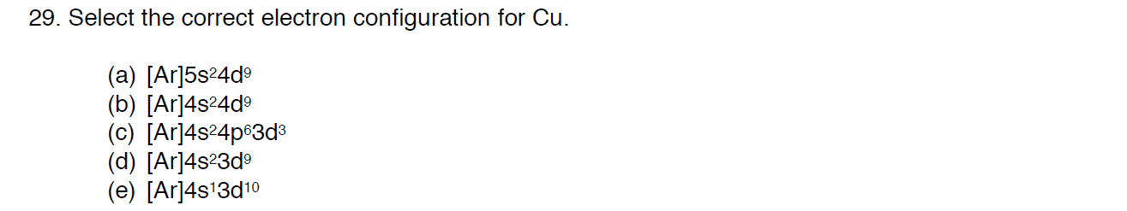

Orbital Diagrams/Pauli Exclusion/Aufbau/Hund’s Rule
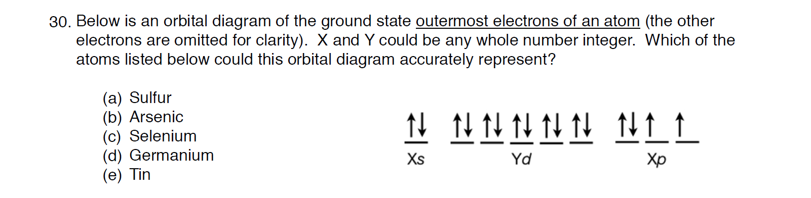
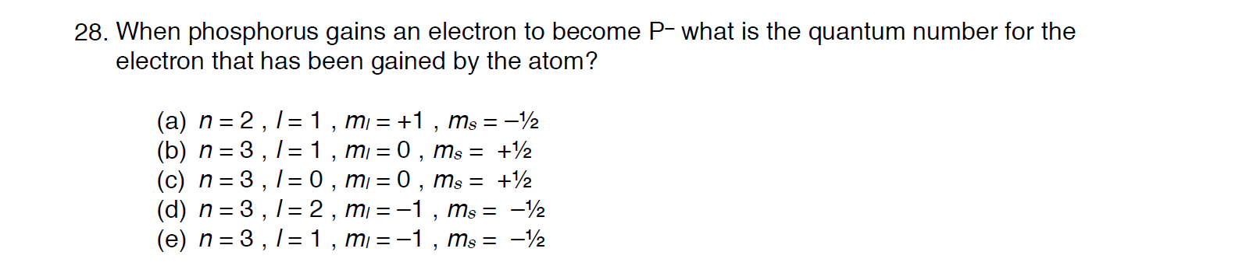
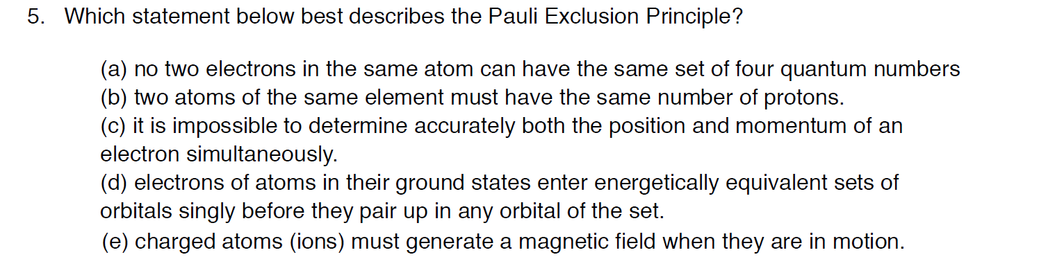
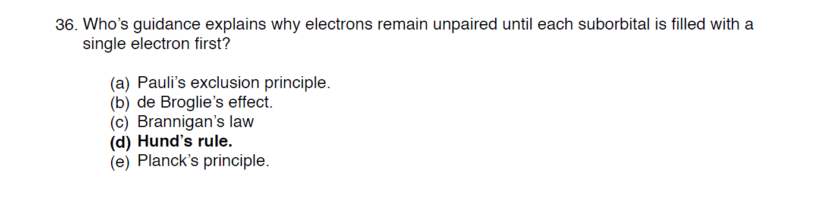
Valence Electrons
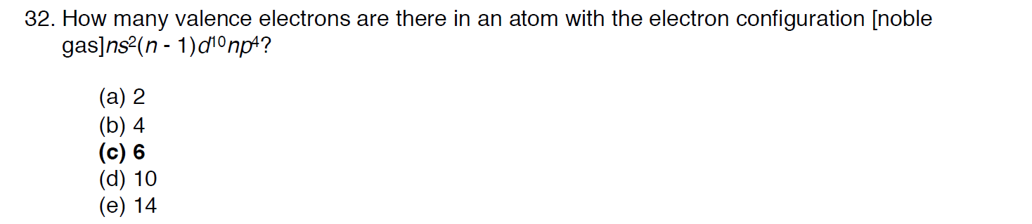

Periodic Trends (radius, IE, EA, electronegativity)
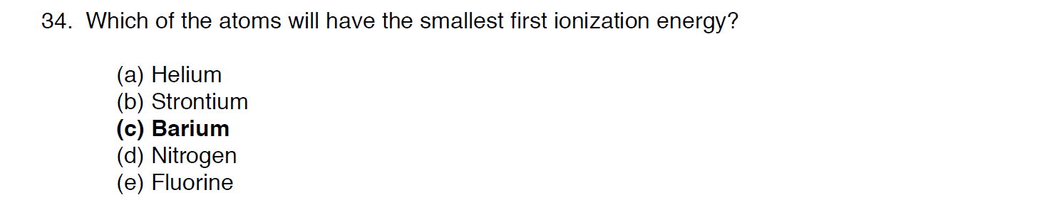
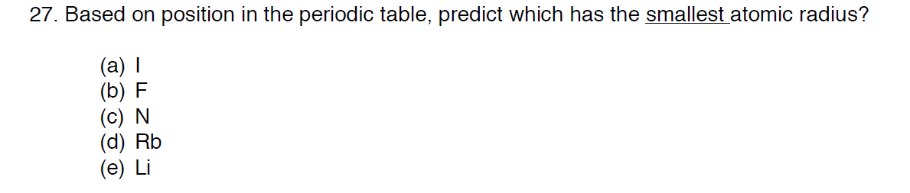
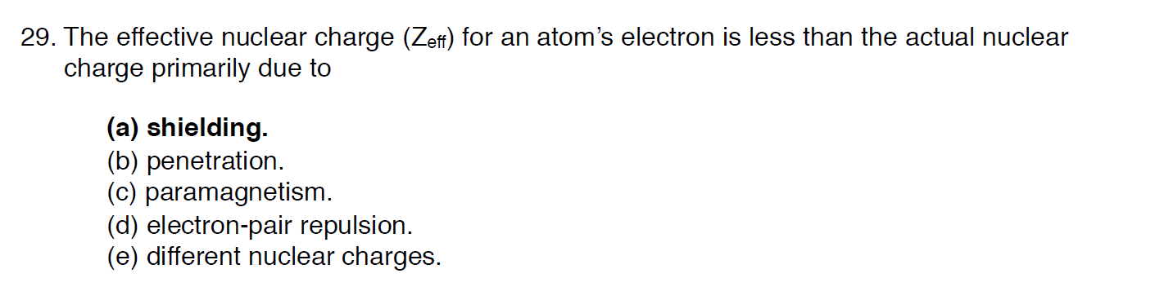
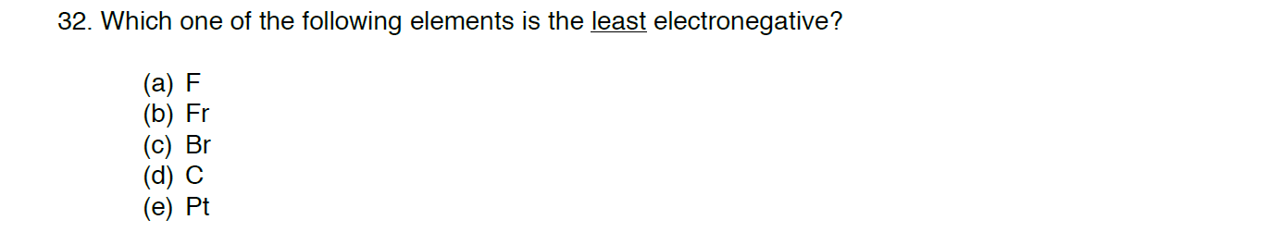
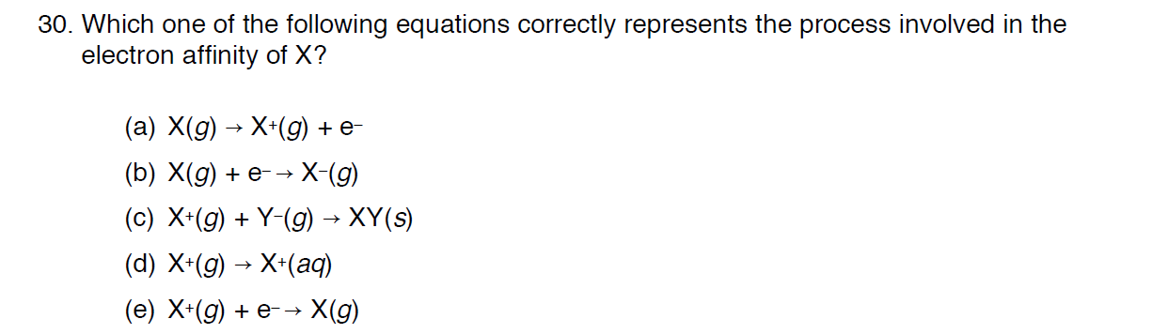

Ionic Radii

Isoelectronic
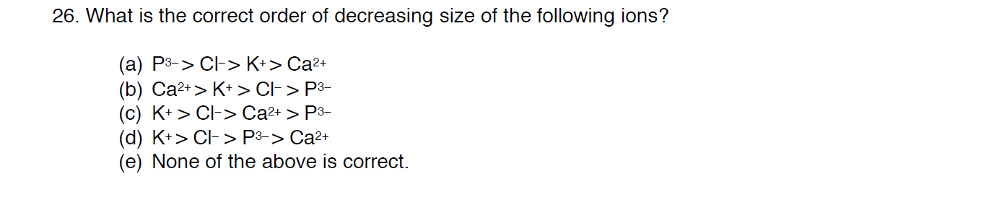
IE1/IE2/IE3 …
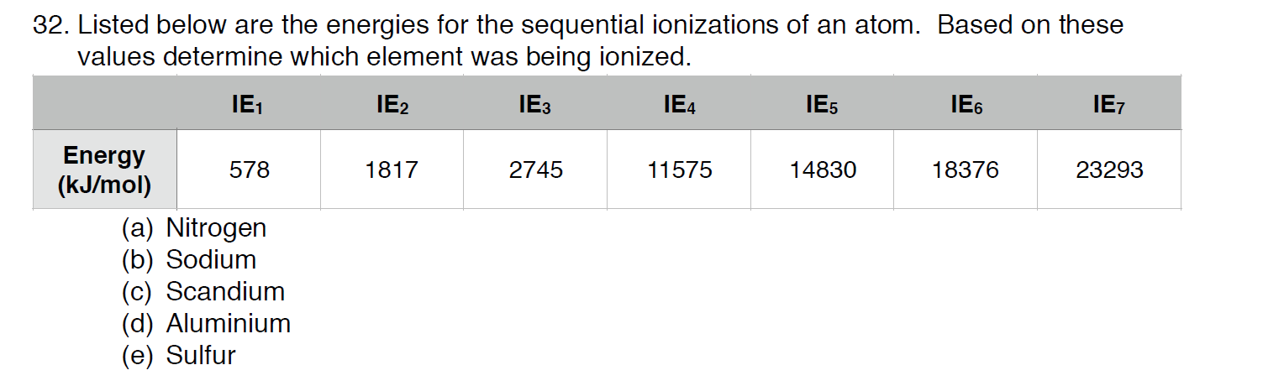
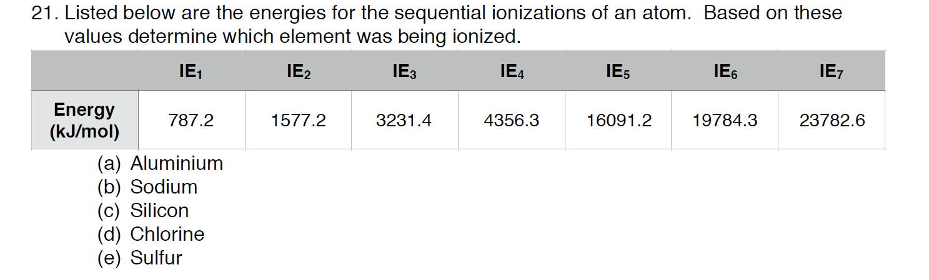
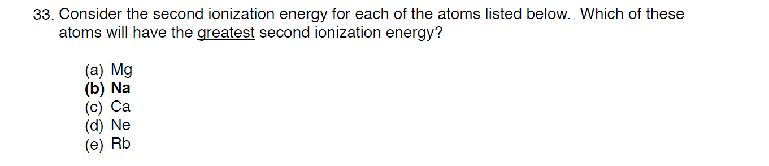

Challenge Problems
